1) Configure Classic Load balancer.

Step 1:  
Launch two EC2 instances running in the same AWS region but in different   
Availability Zones.  
EC2 instances must have a web server

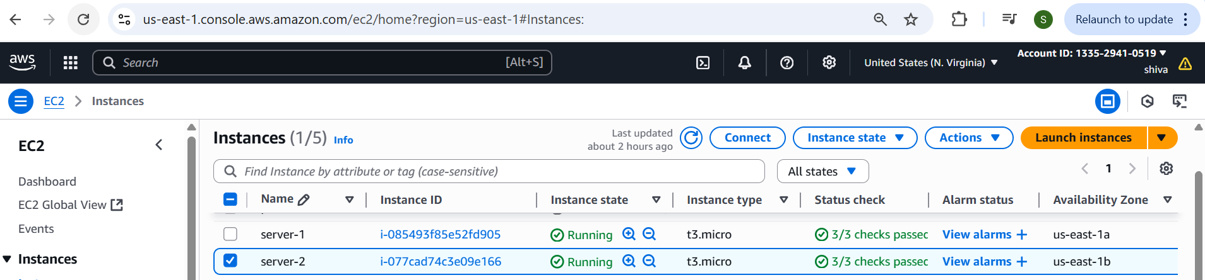

Step 2:  
Create Load Balancer.  
Choose Load Balancer Type  
Select Classic Load Balancer. And click create  
Step 3 — Configure Basic Settings  
Choose Internet-facing (for public access) or Internal (for private access).  
 Listeners:  
Default HTTP: HTTP 80 → HTTP 80  
VPC: Select the VPC where your EC2 instances are located. Availability   
Zones: Select at least two AZs and their subnets.

Step -4  
Register EC2 Instances  
Select the EC2 instances you want behind the load balancer.  
Ensure these instances are in the running state and have the web server running.  
Review settings → Click Create.  
Wait for AWS to provision the load balancer.

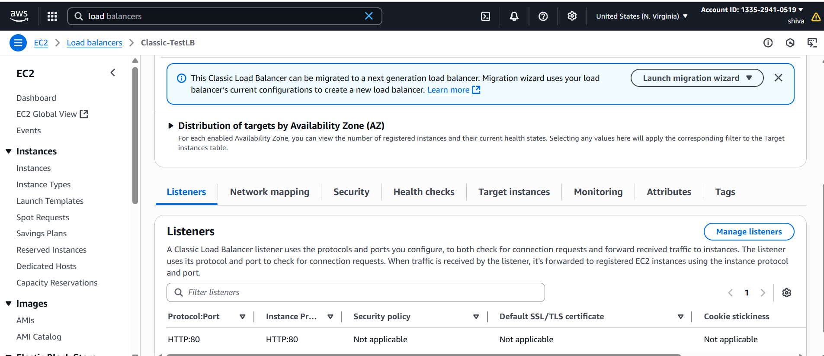

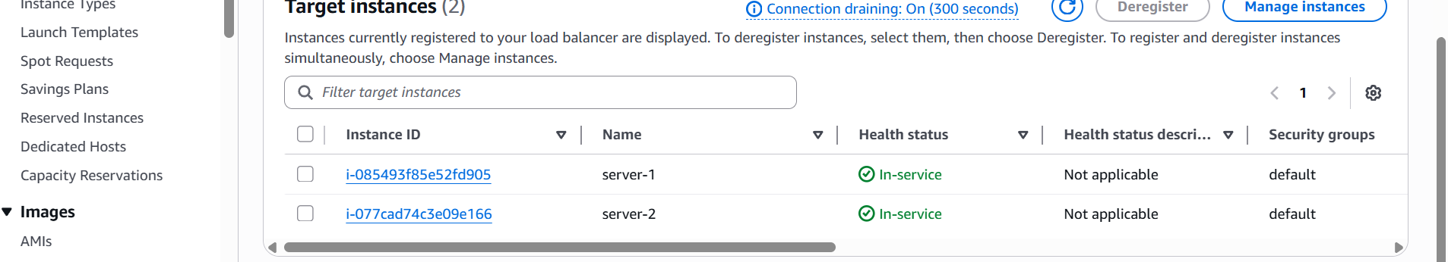

Step 5 — Test  
Once the LB is Active, note its DNS name (ex:- ALB-02-1330657953.us-  
east-1.elb.amazonaws.com)



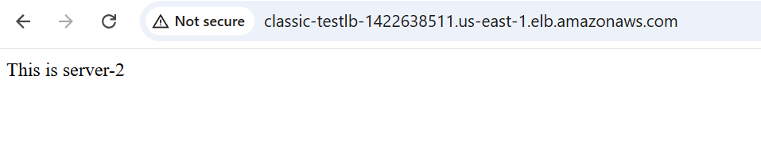

2) Configure Application Load balancer.

Create Load Balancer.  
Choose Load Balancer Type  
Select Application Load Balancer.  
Click Create

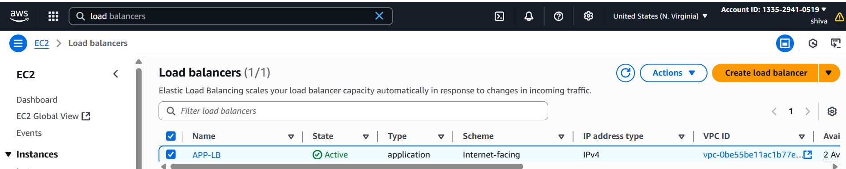

Basic Configuration  
•Internet-facing (for public traffic)  
Listeners: HTTP (port 80)  
VPC: Select your VPC.  
Availability Zones: Select at least two subnets in different AZs

Assign a Security Group that allows:  
oInbound: Port 80 (and 443 if HTTPS).  
oOutbound: Allow to your EC2 instances.

Create Target Group  
•Target group name: my-target-group.  
•Target type: instance  
•Protocol: HTTP

Review and Create  
•Review the configuration.  
•Click Create load balancer.  
•Wait until the ALB’s status changes to Active

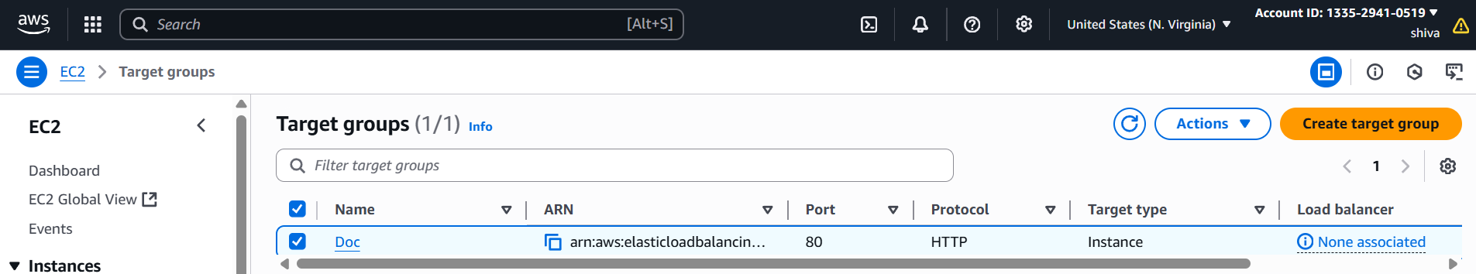

Test  
Copy the ALB DNS name ( App-Loadbalancer-1-1728274351.us-  
east-1.elb.amazonaws.com).  
Open it in your browser → you should see responses from your EC2   
instances.

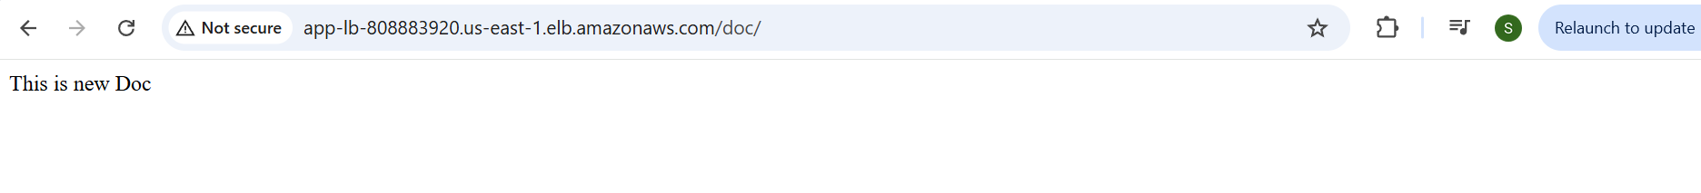

3) Configure Network Load balancer.

Before creating an NLB, make sure you have:  
Two or more EC2 instances in the same VPC, ideally in different   
Availability Zones

Open AWS Console → EC2 service.  
On the left panel, click Load Balancers.  
Click Create Load Balancer.  
Choose Load Balancer Type  
Select Network Load Balancer.  
Click Create.

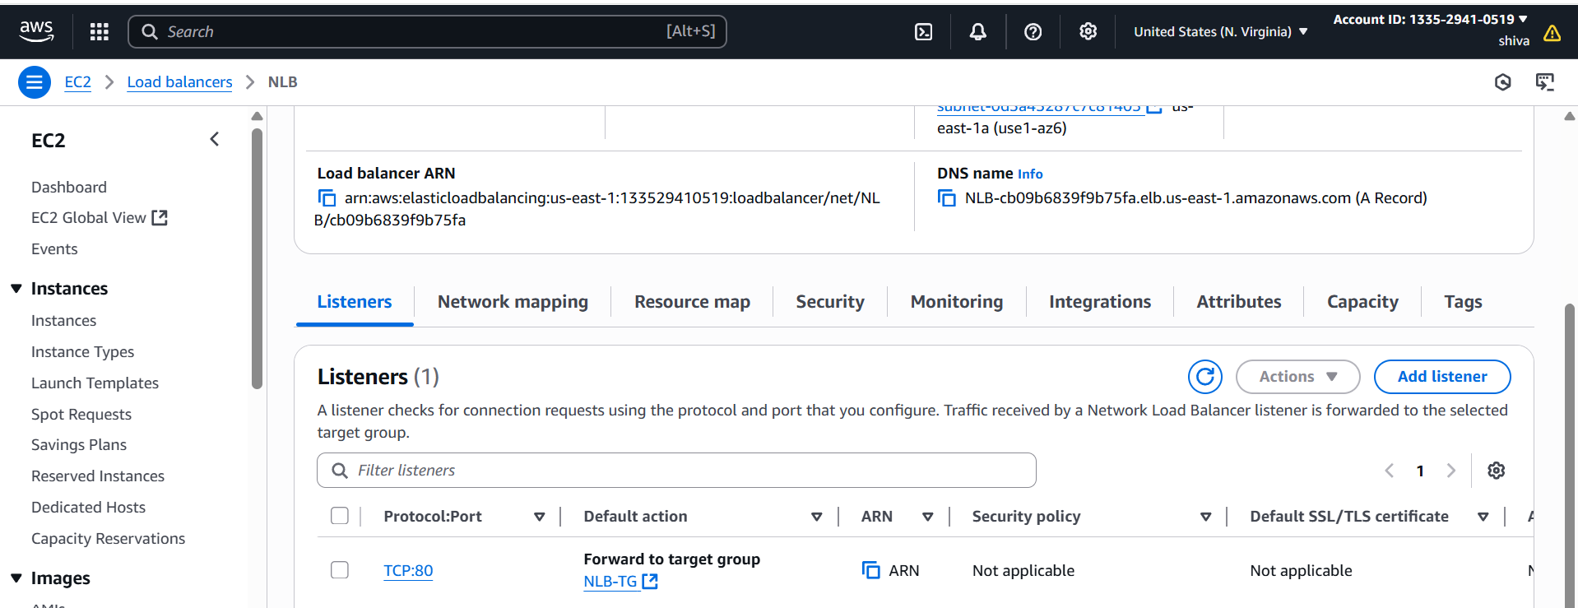

Step 4 — Create Target Group  
Target group name: network-target

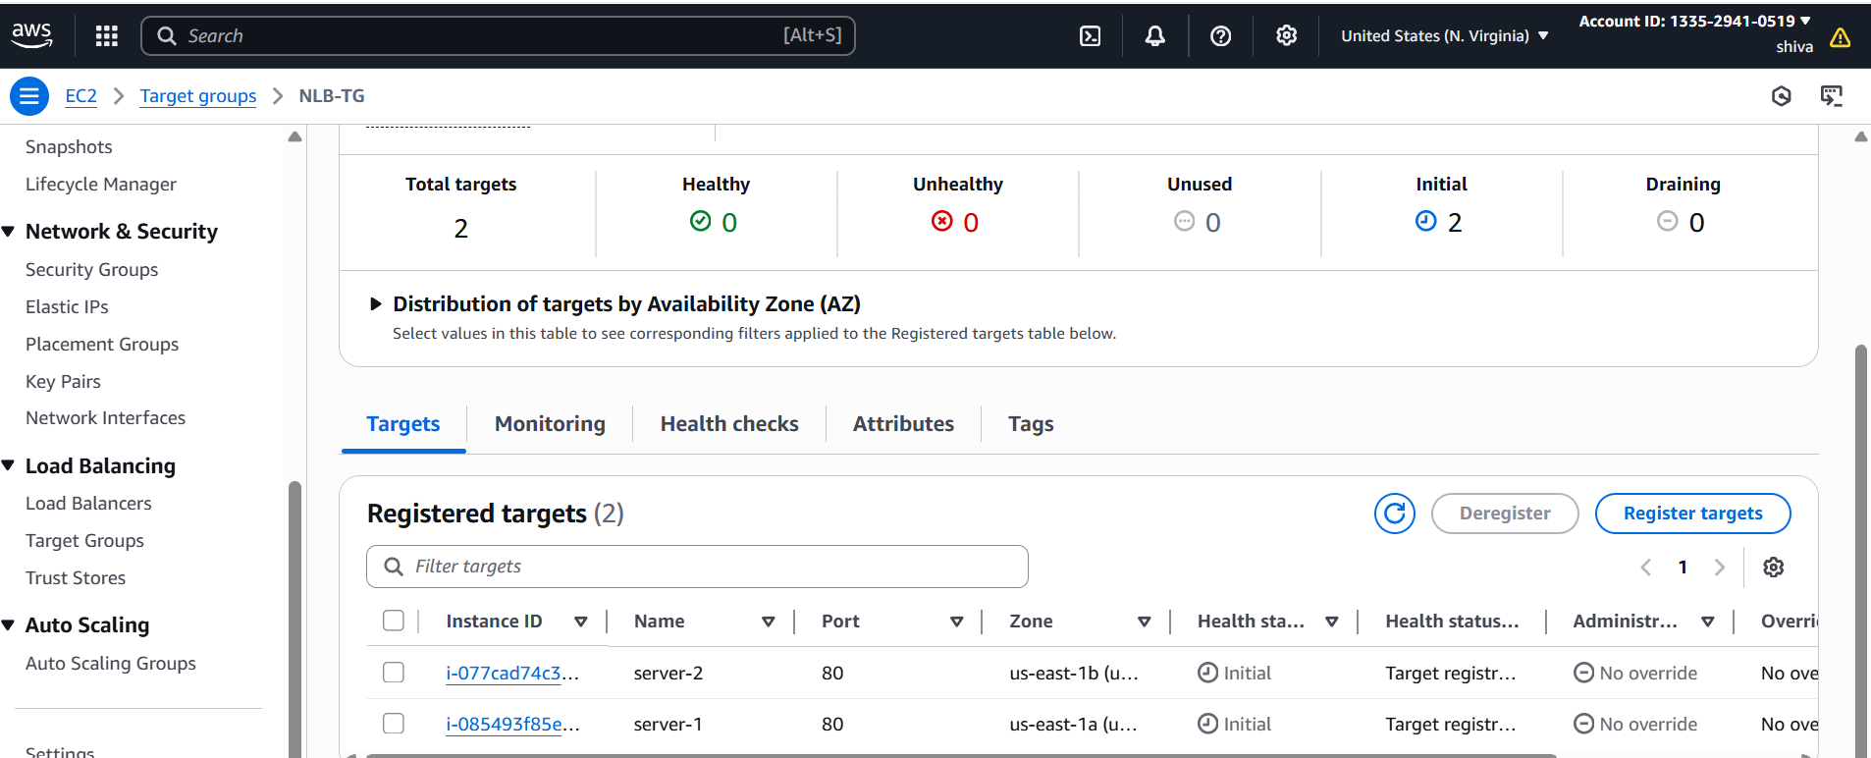



4) Attach SSL for application load balancer.

Get an SSL/TLS Certificate in ACM  
1. Go to AWS Certificate Manager (ACM) in the AWS Console.  
2. Click Request a certificate → Request a public certificate.  
3. Enter your domain name(s) (e.g.,: sunilcloud.shop).  
4. Wait until the certificate status shows Issued.

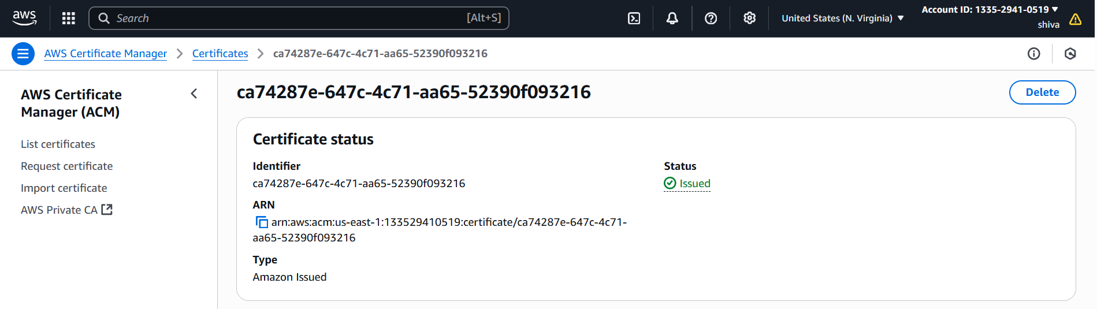

Attach SSL Certificate to ALB  
1. Go to EC2 → Load Balancers in AWS Console.  
2. Select your Application Load Balancer.

3. Go to the Listeners tab.

4. If you don’t have an HTTPS listener

Click Add listener → HTTPS (Port 443) → Add action (forward to your target group)

Under Default SSL Certificate, choose the ACM certificate you created.

Save the changes.

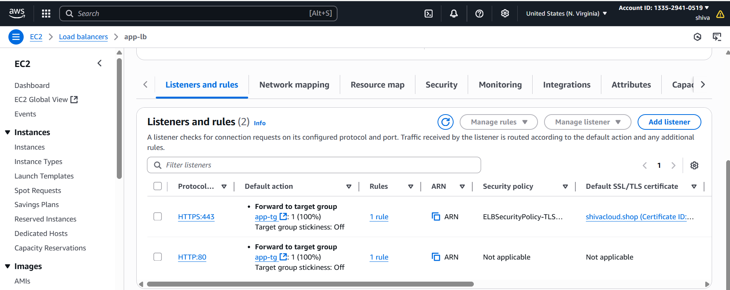

5) Map Application load balancer to R53.

Step-1 Go to Route 53 → Hosted zones.  
Click your domain name (e.g., shivacloud.shop).  
Create record.

Choose:  
•Record name: Leave blank for root domain (example.com) or type   
subdomain (www).  
•Record type: A — IPv4 address (&Cname).  
•Alias: Yes.  
•Route traffic to: Alias to Application Load Balancer.  
•Region: Select the same region as your ALB.  
•Choose load balancer: Select your ALB from the dropdown

Save the record

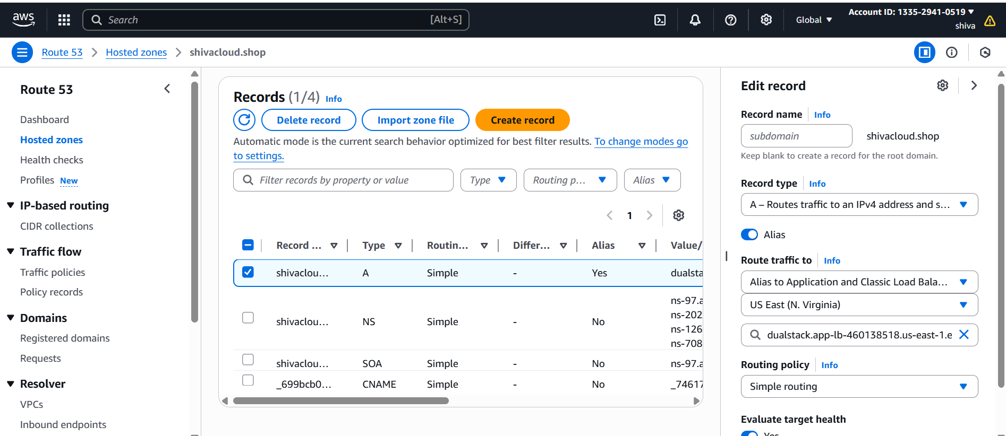

Test:



6) Push the application load balancer logs to s3

Step 1 — Create or Use an S3 Bucket  
Go to AWS S3 Console.  
Create a bucket (example: app-load-logs-1094)

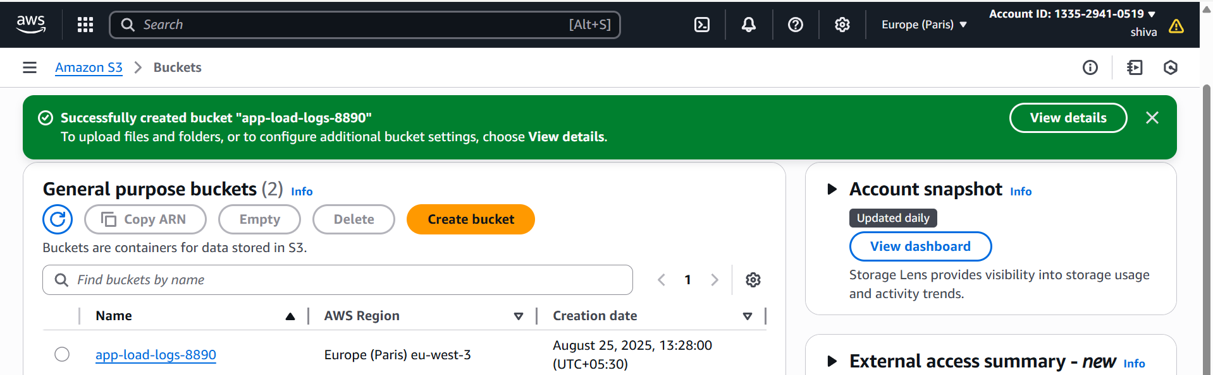

Add Bucket Policy for ALB Logging

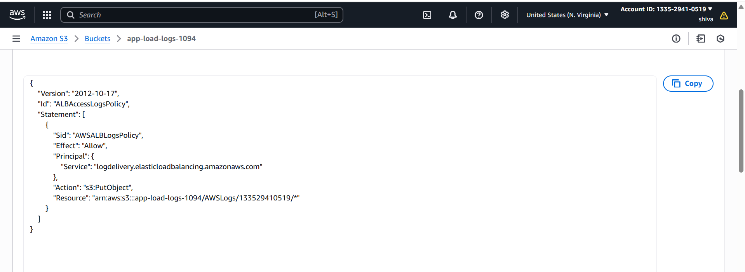

Enable Access Logging in ALB  
Go to AWS EC2 Console → Load Balancers.  
Select your ALB.  
Go to Attributes tab.  
Find Access logs → Click Edit.  
Turn Access logs ON.  
S3 location: s3://<bucket-name>  
Save changes

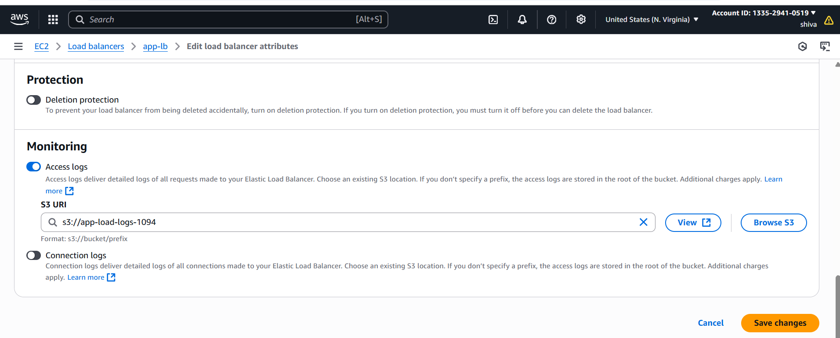

Wait & Verify  
•Logs are delivered every 5 minutes

